Iran-Iraq War (1980-1988)

Student’s Name
Course Name
Date

On September 22, 1980, Iraqi forces invaded Iran, starting the Iran-Iraq war. The Iraqi forces attacked the Iranian airbases by launching airstrikes. They followed by invading the oil-producing regions bordering Khuzestan. This attack was a success with Iraqi troops capturing Khorramshahr city and acquired other territories by November. Iran-Iraq war ended in 1988 after both nations decided to cease-fire in an effective stalemate nearly after eight years of war, leaving nearly one million military troops and civilians dead. The normal diplomatic relations between the two nations did not continue, and they did not withdraw their troops until August 16, 1990, when they signed a formal peace agreement. However, the Iran-Iraq conflict was entirely motivated by religious, political, and territorial conflicts that existed between them since World War 1.
Background Info about the Iran-Iraq War
The tension between Iran and Iraq can be linked with the establishment of the latter nation back in 1921 after World War 1. From 1921 to the 1970s, there was one enduring source of conflict between these nations. It involved the power and control over Shatt al-Arab that served as the waterway established by the confluence of two main ancient and prominent Tigris and Euphrates rivers. Shatt al-Arab was located at the southern end, forming a border between Iran and Iraq. In 1975, the nations signed the Algiers Treaty that reduced the Iraqi's control over the watercourse, and in turn, Iranians were expected to withdraw its support for a Kurdish insurgency North of Iraq. A turning was experienced during the 1978-79 Iranian Revolution that overbalanced the Pro-Western rule that Shah Mohammad Reza Pallavi led. His leadership was favoring a fundamentalist regime Shi’ite Muslim cleric Ayatollah Ruhollah Khomeini led. In July 1979, Saddam Hussein, Iraqi’s president, was worried about the Sunni Muslim population, the nation’s minority and feared that the immense expansion of Iran’s revolution would continue to Shi’ite-dominated in his country. He sought to overturn the 1975 border agreements and regain control over the two sides of Shatt al-Arab that was Iraq's only access point to the Persian Gulf.
Importance of the Iran-Iraq War
The war shaped today's Iraq, Iranian, and Gulf Arab states' leadership in the political and foreign policy outlook. Iraq and Iran came together and agreed to restore diplomatic relations. Iraq agreed with the Iranian terms as a way to settle the conflict between them. The Iraq troops withdrew their military troops from the occupied Iranian territories. This helped strengthen their ties and practice their diplomatic rights with each other agreeing to set a treaty. Both nations released and exchanged prisoners of war as a way to show acceptance and honor the signed agreement. Iran started to penetrate previously impervious regions due to political and ideological spaces starting with Iraq, Syria, Yemen, and Lebanon.
Also, the way helped to establish a road for both nations to becoming a proxy power. During the war, Iran developed its most significant foreign legion, namely Lebanon's Hezbollah. It acquired a super-state status in Lebanon and was seen to supersede the state institutions. It became indispensable as Iran continued to expand its ambitions to Tehran's abilities to train, organize and establish military group in the entire region. With this, both nations managed to maintain their strong power even without being involved in the war. They worked towards building strong connections honoring their peace agreements signed in 1988.
Information about Actual Fighting
In September 1980, the Iraqi military took Iran by surprise by advancing into Khuzestan's broad front. Iraq captured Khorramshahr city, and by December 1980, the Iraqi troops had bogged down nearly 50-75miles inside Iran. The Iranian state militia proved efficient by strongly opposing the Iraq troops. By September 1981, the Iranian troops had successfully pushed the Iraqi troops back across Iran’s Karun River.
The period between 1982 and 1987 was comprised of the intense war between the two nations. In May 1982, the Iranian forces successfully recaptured Khorramshahr from the Iraqi. The Iraq withdrew its forces voluntarily from the earlier Iranian territory it had captured and seeking a peace treaty with the Iranian government. Iran remained intransigent since Ruhollah Khomeini, the Iraq leader, saw Saddam as a great obstacle to the Iranian Islamic Revolution and chose to continue with the war against Iraq, aiming at overthrowing the Iraq leader. Iran plotted fruitless attacks on Iraq, considering that Iraq had powerful firepower and air power. The nations participated in random missile and air attacks on other's cities, oil installations, and military bases. The attacks were mainly focused on the oil-rich regions and continued until 1984 when they attacked the oil-tanker shipping of the other the Persian Gulf. The Iranian attack on tankers heading to and from Kuwait as well as the other Gulf States led the western European countries and the United States to bring warships to the Persian Gulf. This move was to protect the region and ensure a constant oil flow to the rest of the world. The war led to an attack on more than 100 oil tankers drawing international interest and engagement in it. Both countries’ capacity to produce and export oil reduced tremendously due to airstrikes and pipeline shutoffs, resulting in reduced income. This leads to other nations like Saudi Arabia, Kuwait, and the other Arab States financing Iraq. Also, the U.S., together with the Soviet Union, provided support to Iraq against Iran that its major allied Libya and Syria supported.
In 1987, military balance favored Iraq and raised its army to about one million. Iraq received state-of-the-art arms from the Soviet Union and France. The support also included thousands of artillery pieces, armored personnel carriers, tanks, plus hundreds of combat aircraft. Iraq committed a particular amount of its resources in an attempt to buy and create a weapon of mass destruction that included nuclear and biological arms. But, in July 1987, the UN Security Council collectively established Resolution 598 urging Iran and Iraq stop the war, accept a cease-fire agreement, withdraw military troops from boundaries recognized internationally, and resolve their conflicts by holding negotiation meetings under UN auspices. Iraq agreed to this request but demanded that Iran’s terms should be reciprocated. On the other hand, Iran demanded amendments and condemned Iraq for being the aggressor in the war and wanted all foreign navies to leave the gulf.
Early 1988, the Iranian troops, together with Iraqi Kurds, attacked towns to the NorthEast of Iraq's provinces, including Halabjah, Hajj, and Umran. They faced stiff resistance from the Iraqi forces, which used chemical weapons, killing approximately 5,000 Kurdish civilians within and around Halabjah. Afterward, in April 1988, there was a resumption of military operations in the gulf. The Iraqis used chemical weapons to fight the Iranian forces and successfully recaptured the Faw peninsula. Iraq troops continued to liberate the districts of Majnun and Salamcha, and by July, they had penetrated deep into Iran. In the same month, a U.S. missile cruiser was used to shoot down the Iran Air flight 655, a passenger plane mistaken for fighter jet killing 290 passengers on board who were majorly Iranians. This made Iran accept UN Resolution 598 on July 20, 1988. On August 20, 1988, both nations stopped the war and conflict between them.
The Iran-Iraq war was considered to be among the most destructive conflicts of the late 20th century. The nations were fully mobilized with their military underarms. The total number of casualties was estimated to be approximately 1 million to twice the number, with both nations suffering great losses. Also, it is estimated that Iraqi forces murdered around 50,000 and 100,000 Kurds during a sequence of campaigns named Anfal that occurred in 1988.
Conclusion
The Iran-Iraq conflict was a result of religious, political, territorial disputes between the two nations, which escalated after World War 1. The Iraqi forces attacked the Iranian airbases by launching airstrikes, the genesis of the intense war between Iran and Iraq. The Iraqi leader, Saddam Hussein was feared that Iran’s revolution would dominate Iraq and, in turn, choose to attack Iran. Also, he decided to overturn the border treaty both nations signed in 1975 to gain control of Shatt al-Arab to have access to the Persian Gulf. Iranian fought back; they received support from their allies, with Iraq receiving support from Saudi Arabia, Kuwait, some Arab States, and Iran from Libya and Syria. The Iran-Iraq conflict caused the destruction of oil fields in both nations, causing a reduction of oil exportation. In 1988, both nations agreed to end the eight-year war in an effective stalemate after accepting the UN Resolution 598. The war left millions dead. However, as much as the war was greatly dangerous, it was accompanied by positive impacts like Iran starting to penetrate regions previously considered impervious due to political and ideological spaces starting with Iraq, Syria, Yemen, and Lebanon. The war helped to establish a road for both nations to become proxy power. Also, it helped to shape the political as well as foreign affairs policy viewpoint Iran, and Iraq leadership.

Bibliography
Cashman, Greg, and Leonard C. Robinson. An introduction to the causes of war: Patterns of interstate conflict from World War I to Iraq. Rowman & Littlefield, 2021.
Ehsani, Kaveh. "War and Resentment: Critical Reflections on the Legacies of the Iran-Iraq War." Middle East Critique 26, no. 1 (2017): 5-24.
Karsh, Efraim. The Iran-Iraq War. The Rosen Publishing Group, 2009. https://doi.org/10.5040/9781472895400
Kazdal, Melih. “The Iran-Iraq War 1980-1988.” (2020). https://doi.org/10.33201/iranian.706917
Murray, Williamson, and Kevin M. Woods. The Iran-Iraq War: A military and strategic history. Cambridge University Press, 2014.
Takeyh, Ray. "The Iran-Iraq War: A Reassessment." The Middle East Journal 64, no. 3 (2010): 365-383.

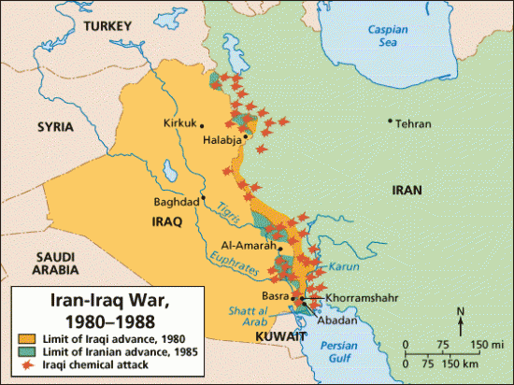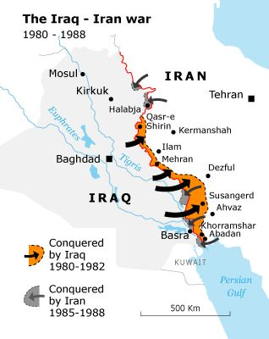

Ehsani, Kaveh. "War and Resentment: Critical Reflections on the Legacies of the Iran-Iraq War." Middle East Critique 26, no. 1 (2017): 5-24.
Cashman, Greg, and Leonard C. Robinson. An introduction to the causes of war: Patterns of interstate conflict from World War I to Iraq. Rowman & Littlefield, 2021.
Karsh, Efraim. The Iran-Iraq War. The Rosen Publishing Group, 2009. https://doi.org/10.5040/9781472895400
Karsh, Efraim. The Iran-Iraq War. The Rosen Publishing Group, 2009.
Kazdal, Melih. “The Iran-Iraq War 1980-1988.” (2020). https://doi.org/10.33201/iranian.706917
Takeyh, Ray. "The Iran-Iraq War: A Reassessment." The Middle East Journal 64, no. 3 (2010): 365-383.
Takeyh, Ray. "The Iran-Iraq War: A Reassessment." The Middle East Journal 64, no. 3 (2010).
Murray, Williamson, and Kevin M. Woods. The Iran-Iraq War: A military and strategic history. Cambridge University Press, 2014.
Murray, Williamson, and Kevin M. Woods. The Iran-Iraq War: A military and strategic history. 2014.
Kazdal, Melih. (2020).

